The Controls and Parameters entities contain logical constructs to help with the physical build and deployment of interfaces. The movement of data which will be contained in this logical model will flow across a variety of interfaces, when this data flows there will be interface file specific attributes which need to be added to the logical data. For example, an interface file may require that a sequence number must be incremented through each interface instance. This sequence number has no place in the logical functional model so it can be captured in the controls and parameters area. Controls and Parameters contains a number of entities to hold this and related interface attributes.
The controls and parameters model has been defined as a generic structure. Many of the attributes contained in this model will be of use to interface developers however not all will always be needed.
It is foreseeable that the control and parameters data model will be extended when physical interfaces are produced. In respect of this the governance model around the control and parameters entities is recommended to be less strict that that of the functional areas of the logical model.
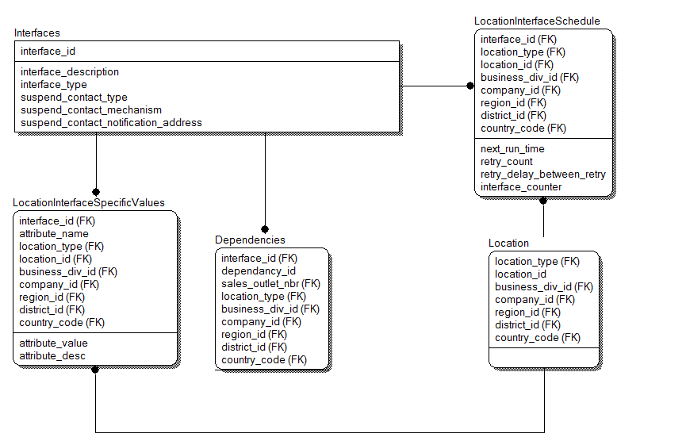
The following section describes the GSLM entities and their attributes which have been modeled as part of the Controls and Parameters scope.

EntityName | Description
Interface | The entity that describes the high level information of the interface
Attribute | Type | Description
interface_id | Number | The unique interface number
interface_description | Text | A description of the purpose of the interface
interface_type | Code | An interface type identifier (batch, realtime, pub/sub etc)
suspend_contact_type | Code | What or who to contact in the event of a suspension (system, person, team)
suspend_contact_mechanism | Code | A way of notifying of suspension (Email, LogFile, Pager)
suspend_contact_notification_address | Text | A notification address to contact
EntityName | Description
LocationInterfaceSchedule | The schedule of the interface by sales outlet
Attribute | Type | Description
interface_id | Interfaces | The unique interface number
location_id | Locations | The target location identifier
next_run_time | DateTime | The scheduled time for the next interface run
retry_count | Number | The number of times and interface should retry in the event of failure
retry_delay_between_retry | Number | The delay in between retry's in the event of failure
interface_counter | Number | A unique counter which may be used by an interface
EntityName | Description
Dependency | The dependencies on interfaces
Attribute | Type | Description
interface_id | Interfaces | The interface that is dependent on something
dependancy_id | Interfaces | The interface that is the dependency
sales_outlet_id | SalesOutlet | The Sales Outlet that this dependency occurs for
EntityName | Description
LocationInterfaceSpecificValue | A generic entity to hold interface specific information
Attribute | Type | Description
interface_id | Interfaces | The interface that has attributes
location_id | Locations | The location that this attribute refers to
attribute_name | VarChar | The attribute name
attribute_value | Text | The attribute value
attribute_desc | Text | Extended text description

